How to download and install the web application

You need to download the sample web application that I found. We will use this application for testing purposes. To run this application we need Node.JS. This is just another framework similar to Java that allows us to run Node.JS applications. The process is similar to what we might do using Nuget in C#.

1. Get [npm here](https://www.npmjs.com/get-npm)
2. [Download the Current version hereDownload the Current version here](https://nodejs.org/en/) for Windows

To check that you have Node.js installed, run this command in a Powershell window:

1. node -v

To check that you have npm installed, run this command:

1. npm -v

**Once you have those installed:**

1. Get the latest code for [react-shopping-cart from my repo](https://github.com/nadvolod/react-shopping-cart)
2. You can just download it as a zip and then unzip. Or, if you know how to use Git, you can clone it

**Once you have the code:**

1. Open a Powershell window and navigate to the folder that contains all of the resources. It will be named "react-shopping-cart". That should be your current directory
2. Run this command to install all of the dependencies, similar to Nuget package manager:
3. /* First, Install the needed packages, similar to Nuget */
4. npm install

It will take a few minutes and will look something like this:

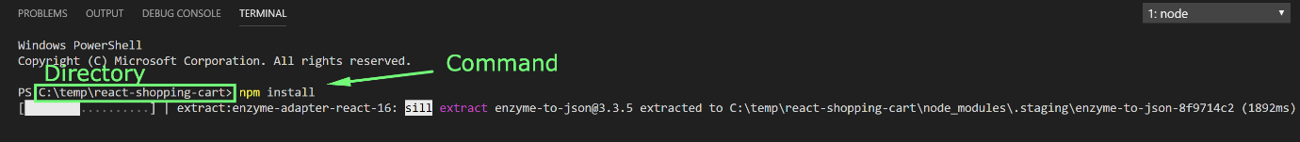

PS: Don't worry about the warnings, they're **not** blockers.

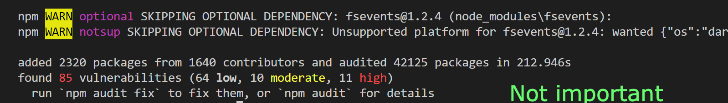

**Once everything is downloaded and installed:**

You can now start the web application on your local machine. Just run the command below in your Powershell window.

1. /* Then start both Node and React */
2. npm start

The next video shows you how to start the application through 2 different methods if you're confused.

**Alternative option:**

If you encounter any issues in installing and running the application or simply do not want to install it locally on your machine, you can use[this URL](https://react-shopping-cart-67954.firebaseapp.com/) instead of the localhost URL for the next tests.